Executive Summary 1
Advanced Therapy Management 2
It’s in Your Genes 2
Why Advanced Therapy? 4
Advanced Therapy Management Basics 4
Therapy Orchestration Framework 5
A Symphony of Coordination 5
A Look Behind the Scenes 6
An Orchestration in Action 9
Apply Multi-Step Scheduling 11
Explore Multi-Step Scheduling 11
Schedule Complex Chains with Ease 12
Verify Booking 13
Reschedule and Cancel Slots 14
Optimize the Network 15
Manage the Chain of Custody 16
Ensure Integrity and Safety 16
Secure the Chain of Custody 17
Customize Chain of Custody Events 18
Explore Compliance and Reporting 20

Executive Summary
Advanced Therapy Management provides a coordinated approach to delivering complex, personalised cell and gene therapies. This document focuses on ex-vivo therapies, in which cells from a patient or donor are processed outside the body before being administered to the patient. Their delivery requires close coordination across treatment centres, manufacturers, logistics partners and other stakeholders, with interconnected activities spanning enrolment, cell collection, manufacturing, infusion and observation.
The platform brings together three core capabilities. Therapy Orchestration structures treatment journeys into stages, steps and tasks, assigning role-specific activities and supporting sequential and parallel workflows. Its data model separates reusable therapy configuration from patient-specific records, enabling organisations to standardise processes while accommodating differences between therapies, sites and regions. Multi-Step Scheduling coordinates linked appointments across locations, accounting for lead times, capacity and site relationships. It also supports booking confirmation, full or partial rescheduling, quotas, allocations and integration with custom scheduling rules.
Chain of custody and chain of identity capabilities provide traceability for biological materials throughout the treatment journey. Unique identifiers link materials to the relevant patient, while configurable custody events, electronic signatures and verification requirements document critical activities and handoffs. Country-specific overrides allow organisations to adapt these controls to local requirements, and consolidated patient custody reports support compliance reporting and audit readiness.
Together, these capabilities are designed to reduce fragmented coordination, improve supply chain visibility and help organisations scale advanced therapy delivery across multiple therapies and geographies. The document explains how workflow configuration, scheduling dependencies, team responsibilities and custody controls work together to support a more coordinated, patient-centred treatment journey.

Advanced Therapy Management
In reactive healthcare systems, patients passively receive care. Treatment is often a standardized, one-size-fits-all approach. When a primary care physician (PCP) prescribes medication, factors such as insurance coverage sometimes outweigh the drug's effectiveness for that specific patient. If it doesn’t work, the PCP tries another, and so on. This trial-and-error approach can inflate costs for chronic conditions, lead to poor health outcomes, and leave patients dissatisfied.
In coactive healthcare, patients are active participants in their own health. Instead of generalized treatment, pharma companies use biomarkers to develop personalized medicines. The result is precision care: fewer adverse effects, less need for high-risk invasive testing, and lower overall costs.

It’s in Your Genes
While modern medicine has made remarkable progress in treating life-threatening diseases and complex disorders, the treatment journey can still be long, arduous, and uncertain. Healthcare professionals struggle with providing the optimal treatment at the correct time, while patients face the anxiety of an uncertain treatment process, its effectiveness, and the road to recovery.
Advanced therapy represents the next frontier in healthcare, harnessing the power of genetics to address the challenges of lengthy and complex treatments. This emerging field, also known as personalized medicine, cell and gene therapy, or chimeric antigen receptor (CAR) T-cell therapy, uses biomarker information for disease prevention, diagnosis, and treatment. With this information, life sciences organizations can design and deliver tailored treatment plans and proactive outcome monitoring based on individual susceptibility to side effects.
Advanced therapy is administered in two ways: in-vivo and ex-vivo. In-vivo therapy involves delivering the medicine directly to the patient, while ex-vivo therapy involves manufacturing the medicine from living cells outside the body before reintroducing it to the patient. This module focuses exclusively on ex-vivo personalized medicine, also known as regenerative therapy.
At the heart of ex-vivo personalized medicine lies gene and cell-based therapy. This treatment involves manufacturing medicine from the living cells of the patient, which is known as autologous therapy, or a donor, which is known as allogeneic therapy. After it is introduced into the patient’s cells, the new genetic material targets and neutralizes mutated genes responsible for causing illnesses.
A typical autologous workflow, such as CAR T-cell therapy, consists of five key steps. Here’s an illustration of those steps and the workflow.
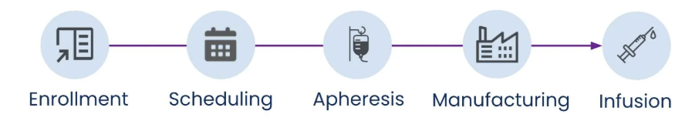
- Intake: Healthcare professionals enroll the patient and prepare them for therapy by obtaining consent, verifying insurance coverage, and placing initial cell orders.
- Scheduling: Scheduling coordinators coordinate a series of appointments to encompass the entire therapeutic journey.
- Apheresis: Medical technicians collect a biosample from the patient’s or donor's living cells. In CAR T-cell therapy, they collect T-cells or lymphocytes from the patient's blood.
- Manufacturing: Laboratory scientists isolate the cells, engineer with the CAR or T-cell receptor (TCR) gene and grow them.
- Infusion: Healthcare providers reintroduce the manufactured biosample into the patient's body. In CAR T-cell therapy, they infuse the engineered T-cells back into the patient's bloodstream.

Why Advanced Therapy?
Advanced therapy is gaining momentum in healthcare because it:
- Consists of a one-off treatment, as opposed to traditional treatments that entail a lifetime of managed care.
- Makes the physician-patient engagement more patient-centric.
- Leads to better health outcomes and improved adherence due to its proactive, preventive approach, as opposed to the traditional reactive approach.
- Provides precision care that reduces adverse drug reactions (ADRs).
- Reduces the reliance on high-risk and invasive testing procedures.
- Lowers overall medical costs as compared to traditional treatments where ADR hospitalizations, trial-and-error dosages, and late-stage diagnosis can drive up costs. Also, gene sequencing costs are low and take less time than most of the existing treatments.
- Helps an aging population that is prone to genetic diseases.

Advanced Therapy Management Basics
Advanced therapy is a rapidly evolving field that demands innovative workflows and rapid turnaround times—from patient to manufacturer and back to the patient. The development and delivery of personalized medicine involve numerous complex steps and a diverse array of stakeholders, including pharmaceutical companies, manufacturers, insurance payers, and providers.
Advanced Therapy Management streamlines the complexities of the end-to-end journey for advanced therapies—from order intake to infusion and observation. It offers flexible and intuitive scheduling capabilities, coupled with optimized supply chain visibility. Together, these features enable pharmaceutical companies to scale their operations across geographies and implement sophisticated scheduling logic.
With Advanced Therapy Management, you can:
- Streamline the delivery of advanced therapies to improve patients’ accessibility and health outcomes.
- Configure multiple therapies on one platform.
- Book apheresis, manufacturing, and infusion appointments, respecting lead times and available capacity.
- Maintain full visibility of custody chains in line with local protocols and regulations, from sampling through administration.
- Activate an intelligent command center that unifies systems across partners, patients, and procedures.

Therapy Orchestration Framework

A Symphony of Coordination
Much like a conductor guiding a complex musical performance, Therapy Orchestration synchronizes the intricate processes involved in advanced therapies. It ensures that the appropriate user takes the necessary action at the optimal time, adapting to the unique challenges of each therapy, regional regulations, and site-specific variations.
With Therapy Orchestration, you design flexible workflows for complex therapies. Each workflow consists of interconnected sub flows, representing the distinct stages of the therapy—from enrolment to infusion. Here’s a representative workflow for the apheresis stage of an advanced therapy divided into key components.
To manage this complexity, a therapy workflow is divided into a clear hierarchy.
- Stages (1): The major phases of the therapy, such as enrollment, scheduling, apheresis, manufacturing, and infusion.
- Steps (2): The primary steps within each stage. For example, the apheresis stage can be divided into sequential steps such as pre-apheresis, before collection, during collection, and after collection.
- Tasks (3): The specific activities that make up each step. For example, the pre-apheresis stage contains specific tasks such as submitting early serology reports, and picking and verifying apheresis kits.
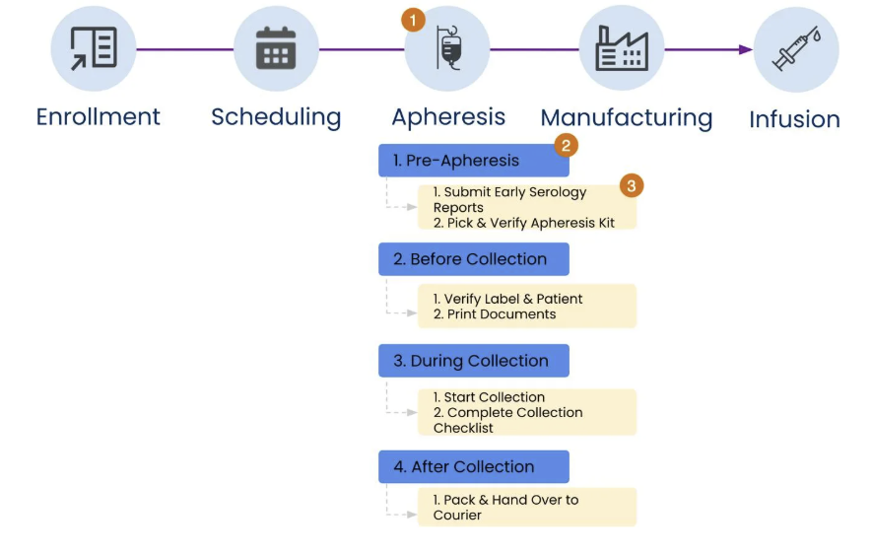
To manage this complexity, a therapy workflow is divided into a clear hierarchy.
- Stages (1): The major phases of the therapy, such as enrolment, scheduling, apheresis, manufacturing, and infusion.
- Steps (2): The primary steps within each stage. For example, the apheresis stage can be divided into sequential steps such as pre-apheresis, before collection, during collection, and after collection.
- Tasks (3): The specific activities that make up each step. For example, the pre-apheresis stage contains specific tasks such as submitting early serology reports and picking and verifying apheresis kits.
Thanks to this hierarchical structure, you can set up workflows involving sequential and parallel processing, accommodating the real-world complexities of advanced therapies.
This framework optimizes team management and role assignment. You can configure care teams for each therapy and site. These teams can even span multiple sites, fostering collaboration and shared responsibility. You can assign each team member a role that translates into contextual activities within the therapy workflow. For instance, a nurse verifies patient identity during intake, while a lab technician prepares samples during apheresis. These users can visualize the therapy's progress and access relevant data within each stage, giving them the information necessary for effective task completion.

A Look Behind the Scenes
Advanced Therapy Management supports these intricate orchestrations with a robust, adaptable data model. By understanding the key records and relationships within this model, you learn how orchestration tools translate into real-world action.
The Advanced Therapy Management data model and how it maps the relationships within Charles’s therapeutic journey.
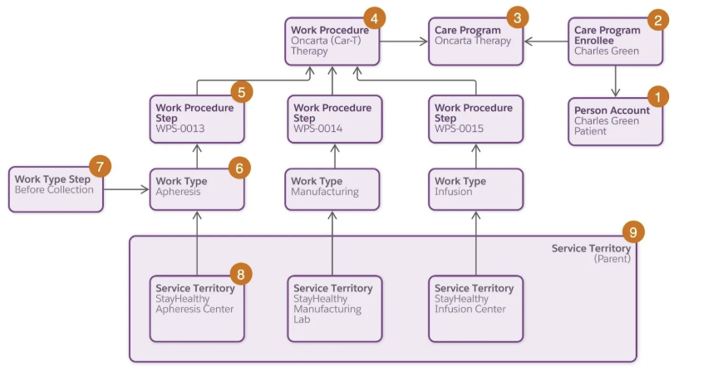
Object | Description | Scenario
Person Account (1) | A person account record combines information from the account and contact records of a patient. | Charles is referred to StayHealthy as a patient.
Care Program Enrollee (2)  Care Program (3) | A care program enrollee record stores information related to a patient in a care program.  A care program record represents a set of activities offered to patients. | Charles enrolls in the Oncarta Therapy care program.
Work Procedure (4) | A work procedure record stores information about a process or program, such as a therapy care program.  You can associate a specific flow orchestration with the work procedure. | StayHealthy Hospital offers an advanced therapy treatment called Oncarta, also known as CAR T-cell, Therapy.
Work Procedure Step (5) | A work procedure step record stores information about a work type that’s part of a work procedure. | The Oncarta procedure involves a series of stages, such as apheresis, manufacturing, and infusion.
Work Type (6) | A work type record represents a category of work. When associated with a work procedure, a work type is referred to as a work procedure step. | Apheresis, manufacturing, and infusion are work types.
Work Type Step (7) | Each work type step represents a specific step within a work type. Each step can be associated with an action plan template that contains specific tasks to complete within the overall step. | Before Collection is a work type step within the Apheresis work type.  A Before Collection action plan template is associated with the record and contains a series of tasks for specific users to complete.
Service Territory (8)  Service Territory (9) | A service territory record set up as a child territory represents a site or location where a work type is performed.  A service territory record set up as a parent territory represents a site that groups all the child service territories where the work types are performed. | Each step occurs at a different site. A parent site, StayHealthy Hospital, groups these sites.

In addition to these objects, which primarily define the setup construct for an advanced therapy workflow, there are additional objects representing the real-time constructs for each patient.
Examine the distinction between these two constructs.
- Setup Construct: This construct involves configuring the foundational elements of the therapy workflow before it's executed for any specific patient.
- Run-Time Construct: This construct involves Salesforce generating real-time records to track a patient's treatment journey after the setup is complete.
Review the table to see how different workflow phases correspond to setup and run-time constructs.
Workflow Component | Setup Construct  (For Each Workflow) | Run-time Construct  (For Each Patient) | Example
Workflow | Care Program, Work Procedure | Not applicable | StayHealthy Oncarta Therapy
Stage | Work Procedure Step, Work Type | Care Program Enrollee Work Order | Enrollment
Step | Work Type Step, Action Plan Template | Care Program Enrollee Work Order Step | Patient Consent
Task | Tasks in Action Plan Template with assigned roles by user or user group | Tasks Flow and Component Tasks | Request Patient Consent, Confirm Consent Receival
Understanding the distinction between setup and run-time constructs is key to implementing workflows that meet the needs of the general therapy and specific patient.

An Orchestration in Action
With the orchestration framework and data model established, follow Charles Green’s journey through the initial stages of his therapy to see the orchestration in motion.
Anita Mandal, the treatment center coordinator, logs in to the Advanced Therapy Management app. This streamlined interface offers easy access to essential features such as Care Programs, Multi-Step Scheduling, and Therapy Orchestration without overwhelming users with unnecessary complexity. From the app, Anita accesses Charles’s Care Program Enrollee record, the central hub for orchestrating his entire treatment journey.
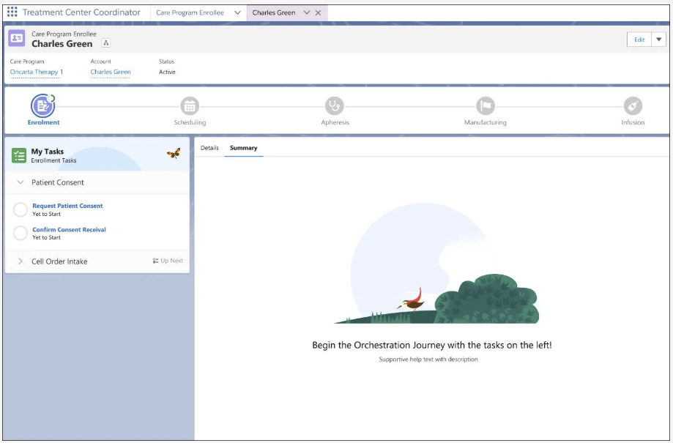
The task pane displays the initial steps for the enrollment stage: obtaining patient consent and initiating the cell order. Each step contains tasks tailored to Anita’s role, ensuring she focuses on her specific responsibilities.
When you click a task, it launches a guided workflow that the therapy provider’s administrators have configured. After you complete the tasks, the orchestration seamlessly transitions to the next step.
For example, after Anita completes the consent tasks, the orchestration then moves to the cell order intake step.
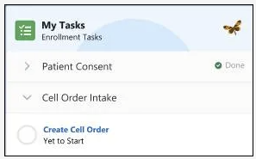 | Next, Anita initiates the Create Cell Order task, which launches a workflow for initiating the therapy purchase details for the treatment.  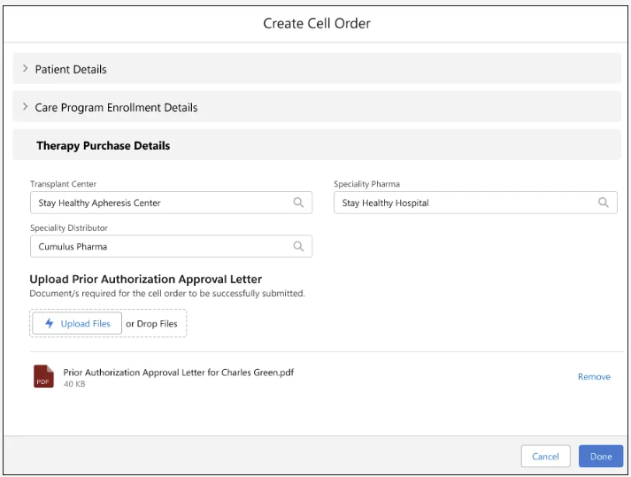

After Anita completes the cell order, the gene therapy coordinator receives a notification. The coordinator’s view of the patient's record presents only the tasks assigned to them. In this case, they review and approve the cell order.
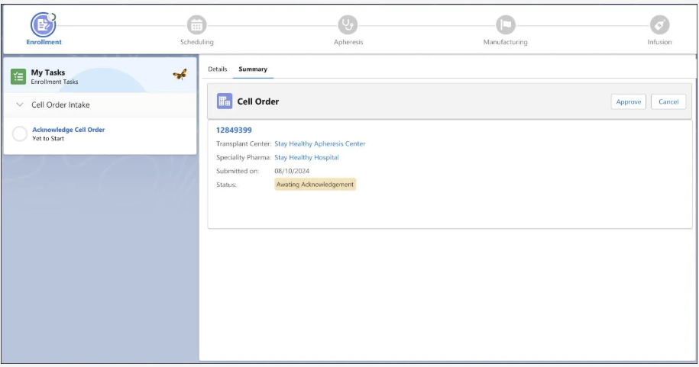
Upon approval, the patient's record advances to the Scheduling stage. Anita now sees new scheduling steps and tasks.
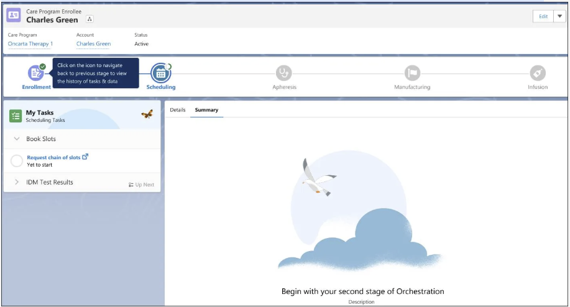
The first step in this stage is aptly named Book Slots, and it’s here that Anita begins the intricate process of coordinating Charles’s treatment timeline. She schedules his apheresis, manufacturing, and infusion appointments, each carefully placed to ensure a seamless and timely therapy journey.
Therapy Orchestration doesn’t just manage complex therapy workflows; it transforms the entire treatment experience. By optimizing workflows and fostering collaboration, it creates a harmonious symphony of care that benefits patients and providers alike.

Apply Multi-Step Scheduling

Explore Multi-Step Scheduling
While the Therapy Orchestration framework provides the blueprint for managing advanced therapies, the actual scheduling of these intricate treatments poses unique challenges. Multi-Step Scheduling rises to this occasion, transforming a potentially complex and error-prone process into a streamlined, efficient operation.
Advanced therapies often involve a series of interconnected steps, each with its own location, timeline, and dependencies. Coordinating these steps manually can lead to scheduling conflicts, delays, and inefficiencies. Multi-Step Scheduling simplifies this by helping you to book appointments for all necessary steps within a single workflow, eliminating the need for fragmented scheduling across disparate systems.
From bio sample collection to product infusion, advanced therapies involve complex logistics across different locations and timelines. Advanced Therapy Management's Multi-Step Scheduling feature simplifies this intricate process, optimizing slot management and multi-step appointment scheduling.
Multi-Step Scheduling transcends mere appointment booking. Explore how this comprehensive solution empowers treatment centers.
- Search efficiently: Find available slots across multiple work types and locations simultaneously, filtering results based on lead times and capacity constraints.
- View optimized results: See the most suitable slot options, saving time and reducing the risk of errors.
- Book appointments seamlessly: Secure a series of interconnected appointments with just a few clicks.
- Reschedule and cancel with ease: Quickly modify or cancel appointments as needed, with options for full or partial rescheduling.
- Manually book slots if needed: Even if a service territory hasn’t published slots, you can manually select and book appointments, ensuring continuity of care.

Schedule Complex Chains with Ease
The concept of lead time—the time required between therapy treatment steps—is central to effective scheduling. For instance, if a patient’s apheresis procedure is scheduled for December 1, and it takes a day for the sample to reach the manufacturing site, the earliest available manufacturing slots would be December 3. Multi-Step Scheduling intelligently incorporates lead times into the booking process, ensuring that subsequent appointments are scheduled only when the preceding steps are complete and any necessary processing or transportation time has elapsed.
To further enhance scheduling efficiency, administrators can define relationships between affiliated sites and map site-to-site connections. These service territory relationships define the routes that constitute the series of appointments, helping to refine search results and present the most suitable options.
Manually coordinating these appointments is a logistical nightmare, requiring treatment center coordinators to juggle multiple screens, consider lead times, and potentially reschedule if any dates conflict. Multi-Step Scheduling comes to the rescue, consolidating all this information into a single, intuitive interface.
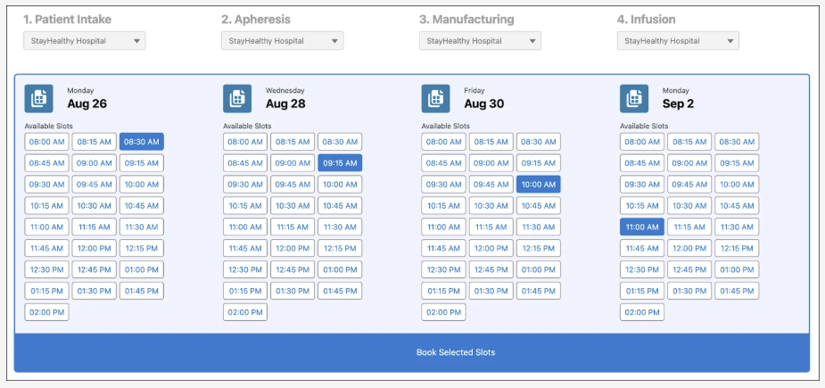
The scheduler presents staff with a consolidated view of available slots for intake, apheresis, manufacturing, and infusion, considering lead times and capacity constraints. They can easily toggle between different service territories to find the most suitable options for the patient.
With the ideal slots selected, the staff books them. A Review Request Summary window appears, and they verify the details before submitting the booking request.
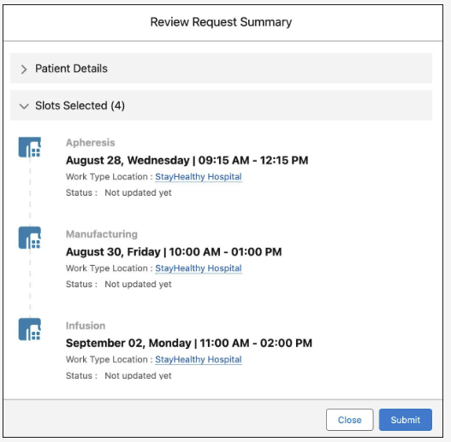

Verify Booking
Advanced Therapy Management offers an automated flow that helps you verify and accept booking requests. To make the flow accessible, add the Confirm Booking Request button to the care program enrolee record page.
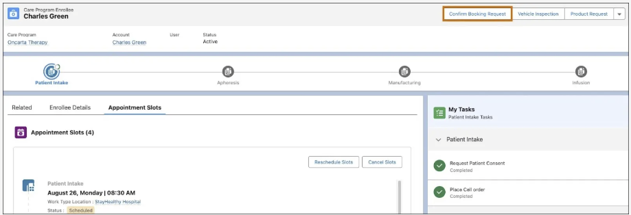
After staff books slots for the patient’s apheresis, the gene therapy coordinator verifies the request with a few easy steps and changes the status of the requested appointments to Scheduled.

Reschedule and Cancel Slots
Unexpected events are not uncommon in the world of advanced therapies. Patient availability changes, logistics delays occur, and the manufacturing process requires adjustments. Thankfully, Multi-Step Scheduling is designed to adapt to these uncertainties.
Let's say the patient is no longer available on the originally scheduled date for his apheresis procedure. This requires rescheduling not just one appointment but potentially the entire chain of appointments that follow.
With Multi-Step Scheduling, you have two options.
- Full chain rescheduling: If the change affects the first step in the chain, apheresis, you can initiate a full chain rescheduling. This means all subsequent appointments, such as manufacturing and infusion are automatically adjusted to accommodate the new apheresis date.
- Partial rescheduling: If the change only affects a later step in the chain, for example infusion, you can opt for a partial rescheduling. With this option, you adjust the impacted appointments without disrupting the earlier steps in the process.
You can initiate the rescheduling process from the patient’s Care Program Enrollee record. The intuitive interface guides you through the steps so you can easily select the appropriate work type for rescheduling and then conduct a new search for available slots.
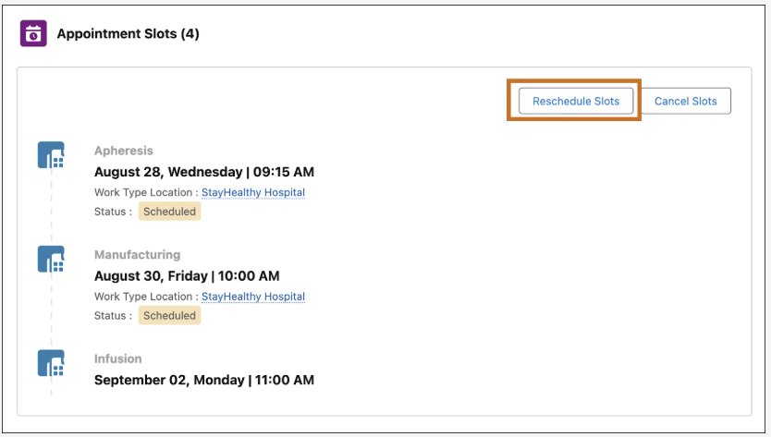
The scheduler considers the new date constraints and presents you with updated options, ensuring a smooth and efficient rescheduling process.
To manage the patient’s rescheduling, staff selects the Apheresis work type and performs a full chain rescheduling with ease.
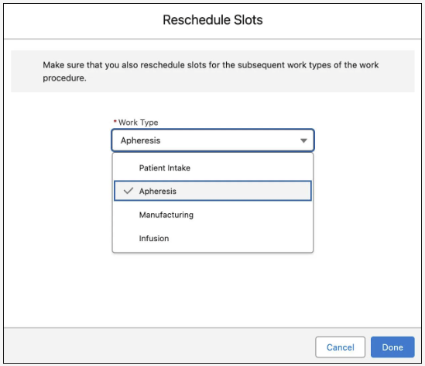

Optimize the Network
The complexities of advanced therapy management extend beyond individual appointments. The entire network of treatment centers, manufacturing sites, and logistics partners work in harmony to ensure timely and efficient care delivery. Multi-Step Scheduling offers a range of features designed to optimize this network and accommodate the unique requirements of each therapy and location. Click each feature to learn more.
Task | Description
Site Relationships and Prioritization | Define relationships between sites with varying capacities and capabilities, such as parent-child service territories.  For example, StayHealthy Hospital serves as the parent territory for multiple apheresis and infusion centers. Additionally, you can prioritize specific site-to-site relationships, optimizing scheduling and transportation lead times.
Quotas and Allocations | Prevent overbooking and delays, and ensure fair distribution of resources by configuring quotas for treatment centers and allocations for manufacturing sites.
Scheduling Preferences by Therapy | Advanced therapies sometimes have unique scheduling needs, such as specific lead times between stages. To account for these nuances, set conditional rules.  For example, a patient can reschedule their infusion. Conditional rules can be based on various factors, such as the number of days since manufacturing completion. These rules ensure flexibility while adhering to the specific rules of each therapy.
Non-schedulable Processes | Multi-Step Scheduling also accommodates non-schedulable process steps, such as cryopreservation or logistics, which impact downstream appointments but don't require dedicated booking slots.
Advanced Integrations | For even more advanced customization, scheduling APIs are exposed, so healthcare providers can integrate their own custom logic and business rules into the scheduling process.
Flexible scheduling options help you accommodate last-minute delays and changes. All of this together ensures the patient is well on their way to recovery.

Manage the Chain of Custody

Ensure Integrity and Safety
Think of a patient’s cells as precious cargo on a complex journey from collection to infusion. Every step must be meticulously documented in a chain of custody, a continuous record showing the whereabouts and handling of each patient’s unique biological material. Regulatory bodies worldwide mandate this process to ensure transparency, accountability, and, ultimately, patient safety.
Advanced Therapy Management provides life sciences organizations with robust chain of custody and chain of identity features to meet this crucial requirement. The chain of custody records every handoff, modification, and signature, creating an irrefutable record of the therapy’s journey. Meanwhile, the chain of identity assigns a unique identifier to the collected biosample, ensuring the appropriate treatment reaches the patient. Admins can configure which events trigger chain of custody updates and the level of electronic signature required, offering both control and flexibility.

Secure the Chain of Custody
To illustrate how Advanced Therapy Management maintains the critical chain of custody, revisit Charles Green. His CAR T-cell therapy is now in the apheresis stage.
The data model for the chain of custody is quite straightforward. Study the key objects involved.
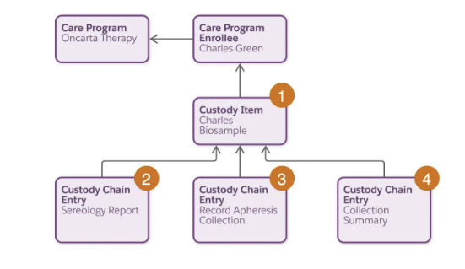
Object | Description | Scenario
Custody Item (1) | This object represents information about an item in the custody chain. Add a unique identifier to maintain a unique chain of identity throughout the process. | Charles enrolls in the Oncarta Therapy program and is assigned a unique identifier that links to his care program enrollee record.  This identifier serves as a digital fingerprint, ensuring that his cells are never confused with those of another patient.
Custody Chain Entry (2, 3, 4) | These objects represent information about an entry or event in the chain of custody. | During the apheresis stage, the StayHealthy team completes Charles’s serology report, records his apheresis collection, and produces a collection summary.
You can create custody records automatically as part of your therapy orchestration, greatly enhancing the intricacy and flexibility of the chain. Use prebuilt flows to seamlessly link your therapy orchestration with chain of custody requirements.
Task | Description
Override Custody Verification Type When Work Order is Changed | This flow creates the related custody records when a specific stage, such as apheresis, is in progress.
Override Custody Verification Type When Work Order Step is Changed | This flow creates the related custody records when a specific step, such as identity verification, is in progress.
Evaluate Step and Task Completion Status | This flow checks whether custody of a biosample for each step and task has been fulfilled.
Process Advanced Therapy Work Orders | This flow checks whether custody requirements are met and moves to the next orchestration step.

Customize Chain of Custody Events
Not every event needs a chain of custody record. Advanced Therapy Management teams can designate precisely which stages, steps, and tasks in the therapy orchestration trigger a chain of custody event. This level of granularity ensures that the chain of custody captures only the most critical information, avoiding unnecessary clutter while maintaining regulatory compliance.
For example, during the apheresis stage, StayHealthy creates two steps, Before Collection and After Collection, each with its own set of tasks.
Step | Task | Chain of Custody Event?
Before Collection | Serology Report | Yes
Before Collection | Print Documents | No
During Collection | Collection Start | Yes
During Collection | Collection End | Yes
During Collection | Collection Checklist | Yes
During Collection | Collection Summary | Yes
The Before Collection step contains two tasks, but only the Serology Report task requires a custody chain entry. The During Collection step contains four tasks. However, the Start, End, and Checklist tasks combine into a single custody chain entry, while the Collection Summary task requires its own custody record.
You can further customize flows and decision tables for scenarios requiring signatures to verify the chain of custody. For each work order, work order step, or task where the custody item requires verification, create a digital verification setup. The record serves as a signature trail, setting up the number of required signatures and determining if designated verifiers must sign the records in a specific order. For example, this screenshot shows the setup for confirming Charles’s identity during apheresis collection.
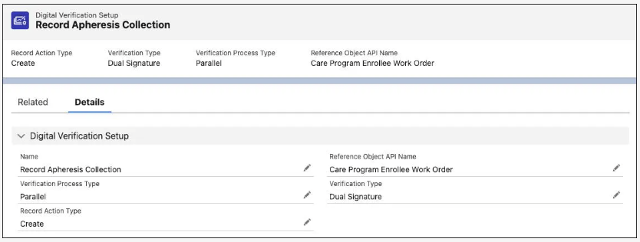
To record apheresis collection, StayHealthy sets up a parallel verification requiring dual signatures. This means that two signatures are required and they must be signed in a specific order.
Next, create a custody verification type override record that links the signature trail to the appropriate work type details and, by extension, custody chain entry. For example, StayHealthy creates an override record for recording the apheresis collection.
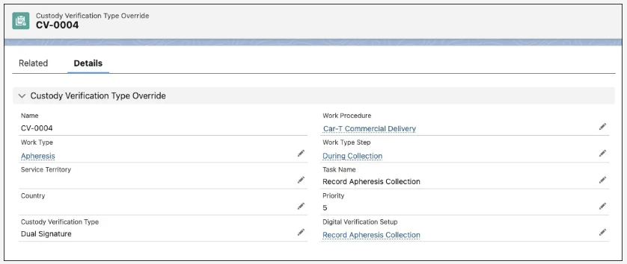
This record links to the verification setup record for recording apheresis. And it links to the appropriate work procedure, work type, and work type step related to the task. When the nurse and treatment center physician verify the apheresis collection, a dedicated custody chain entry stores all the details about the verification.
Here’s a sample chain of custody configuration for two steps in the apheresis stage with the signature type added.
Step | Task | Signature Type | Signer 1 | Signer 2
Before Collection | Serology Report | Single | Apheresis Nurse | —
Before Collection | Print Documents | — | — | —
During Collection | Collection Start | Dual | Apheresis Nurse | Treatment Center Physician
During Collection | Collection End | Dual | Apheresis Nurse | Treatment Center Physician
During Collection | Collection Checklist | Dual | Apheresis Nurse | Treatment Center Physician
During Collection | Collection Summary | Dual | Apheresis Nurse | Treatment Center Physician
Notice the signature configurations for each task.
- The serology report requires only a single signature, which is assigned to the apheresis nurse.
- The Print Documents task doesn’t require any signatures.
- Three collection tasks combine into a single chain of custody event and require dual signatures from both the apheresis nurse and treatment center physician.
- The collection summary task also requires dual signatures from the nurse and physician.
To satisfy local regulations without needing separate workflows, organizations can also specify country-specific overrides for chain of custody events and signature requirements. For example, a label verification stage requires dual signatures in one country but doesn’t even require a chain of custody event in another. You can easily customize decision tables to manage these rules.

Explore Compliance and Reporting
Finally, to ensure compliance and audit readiness, Advanced Therapy Management provides the ability to generate detailed patient chain of custody reports. These reports consolidate all the chain of custody records, presenting a comprehensive overview of the entire therapy journey. With customizable reporting options, you can tailor the information displayed to meet specific regulatory requirements or internal needs.

